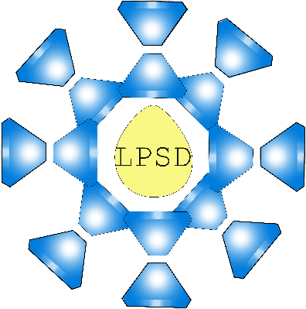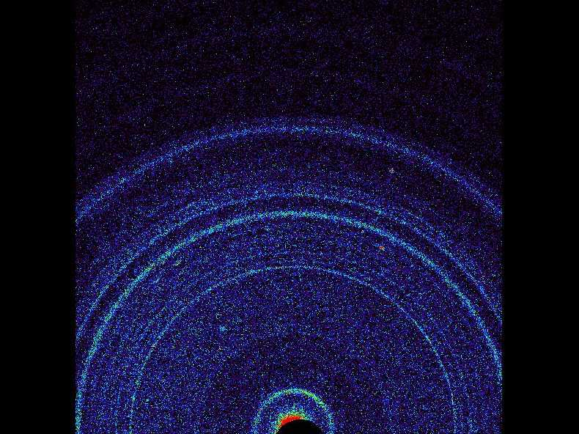

HXMA Pressure to Diffract Guide

SPEC Python GUI

Michael Hamel | Oct 29th 2016

# Quick Guide

## SPEC

First you must start the SPEC server: 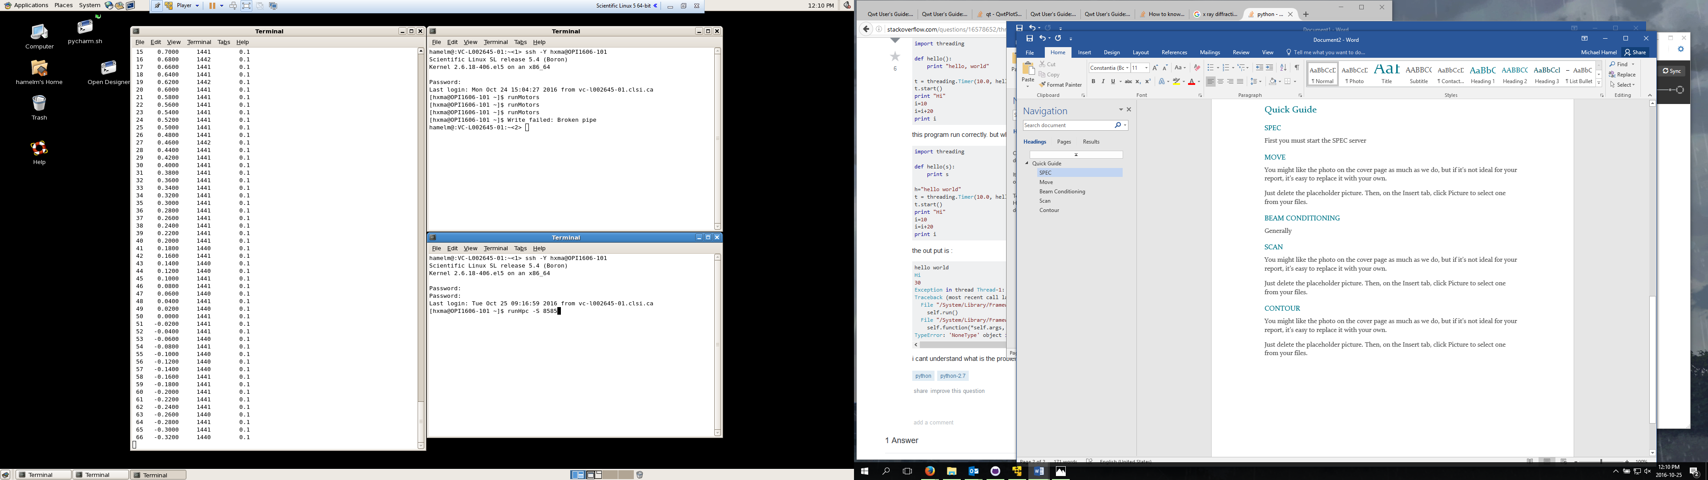

Sstupid0

Currently this is how you would start the server from any computer inside the firewall.

## Move

For the purposes of the quick guide I will assume that the motors are setup from a previous user. If they are not please refer to MOTOR SETUP. 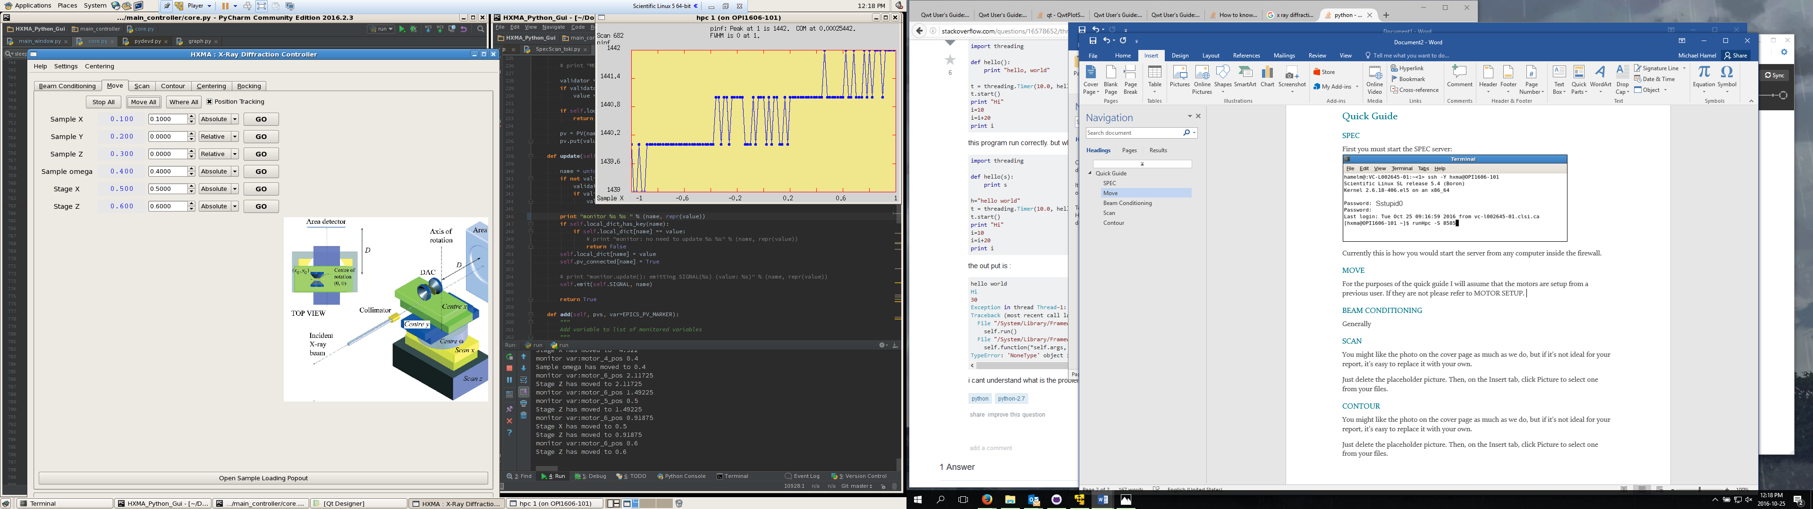

The GUI should look like this, and will allow you to move each motor to the desired position, the positions next to the names will update in real time, if you would like to stop this you can turn off Position Tracking. The “Stop All” button will only stop moving motors, and will also kill scans.



The button at the bottom of the page opens the cell loading/saving page. Please refer to CELL LOADING for details.

## Beam Conditioning

Beam Conditioning is very similar to Move, except we have two ways of moving the motors here, either through SPEC or EPICS. The EPICS ones are hardcoded in and should always work well and the SPEC ones will need to be configured on the SPEC server, but you will be able to do scans/contours with them.

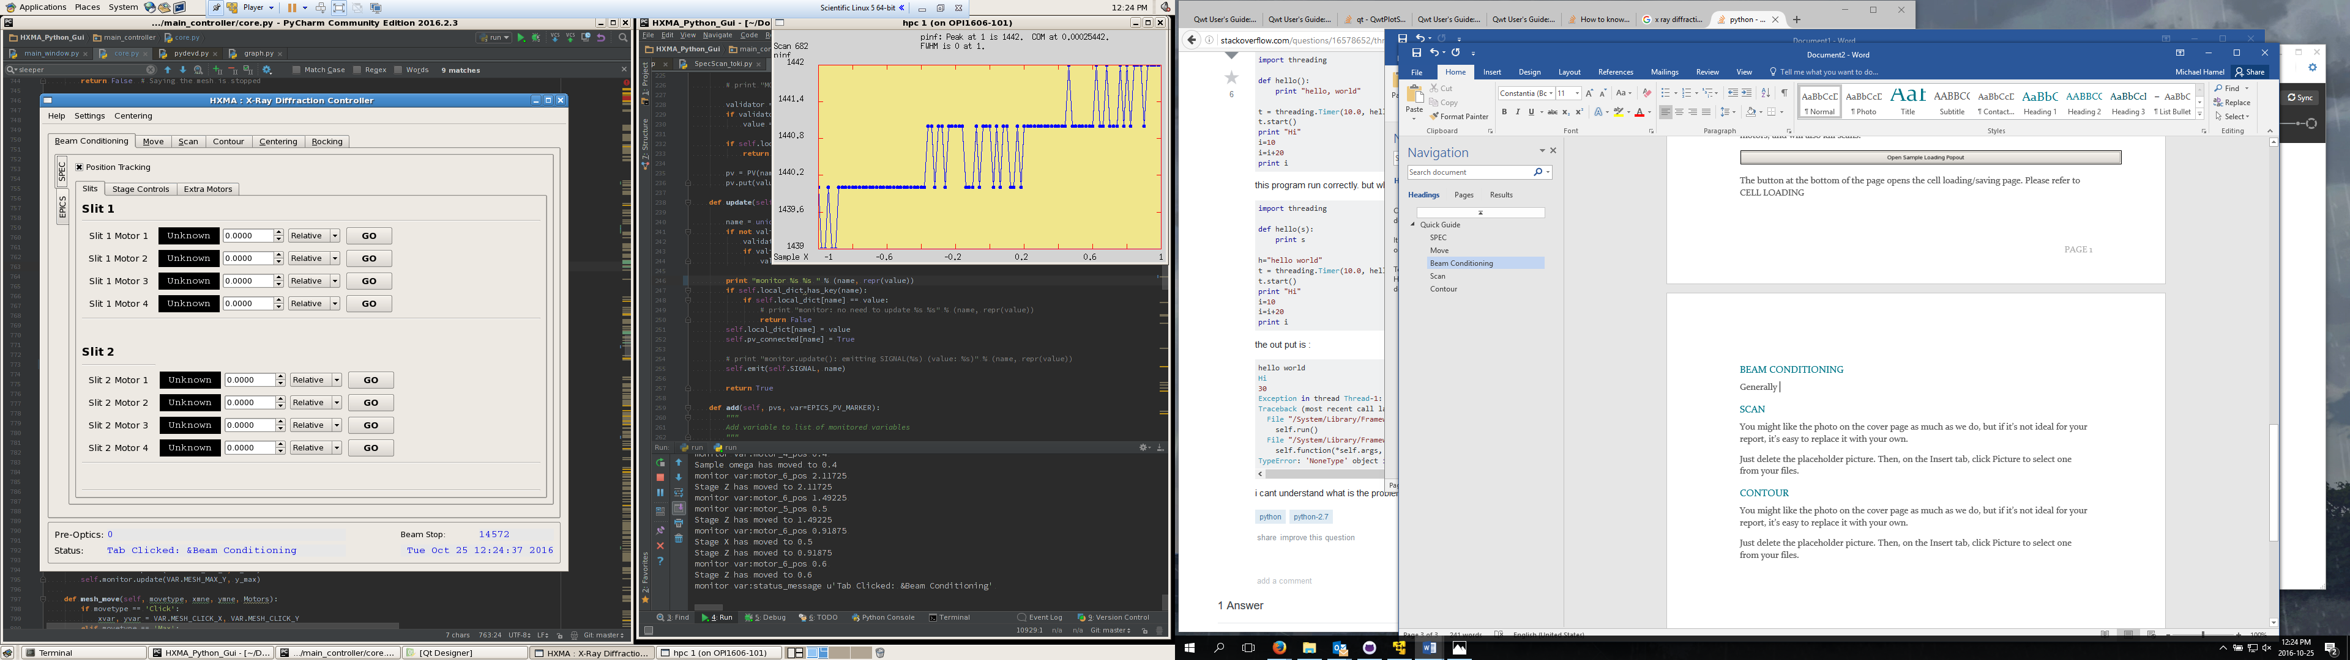

## Scan

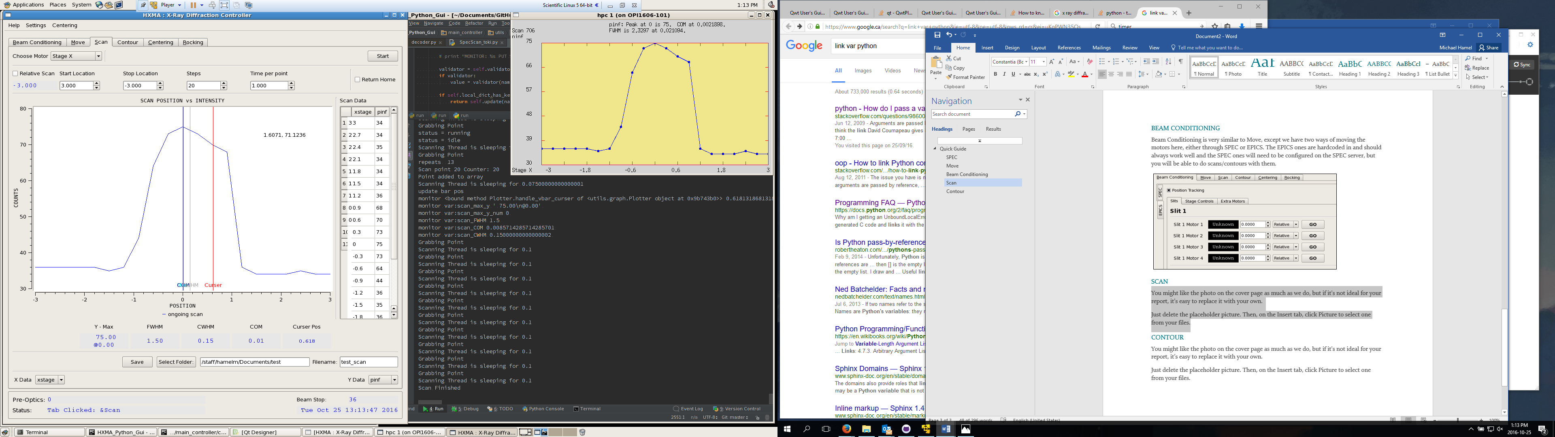

**Double Click Value to move to**

**(once scan is complete)**

**Choose Data to display**

**(updates when scan begins)**

**Input Settings before scan here**

Above is an example of a completed scan, we can see that the bars are showing the calculated values, we also note that the “Curser” bar can be clicked and dragged.

The scan can be saved at any time and if a directory + name is specified beforehand, automatic backups are made.

## Contour

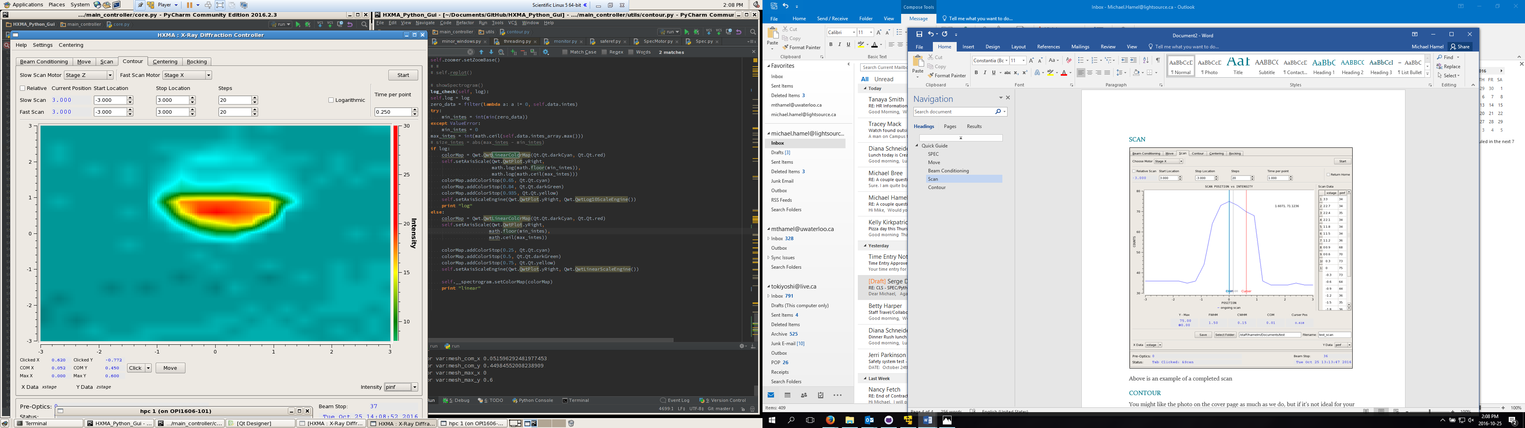

**Move to Value**

**(once scan is complete)**

**Choose Intensity Data**

**Pre-Scan Settings**

Above is a Mesh/Contour scan, which lets you scan two motors for the intensity.

Note that the graph axes are set to the chosen motors. You can change the data which displays as intensity and the scaling method to logarithmic if needed.

## Centering

**Pre-Scan Settings**

**Move to Value**

**(once scan is complete)**

**Choose Data Display**

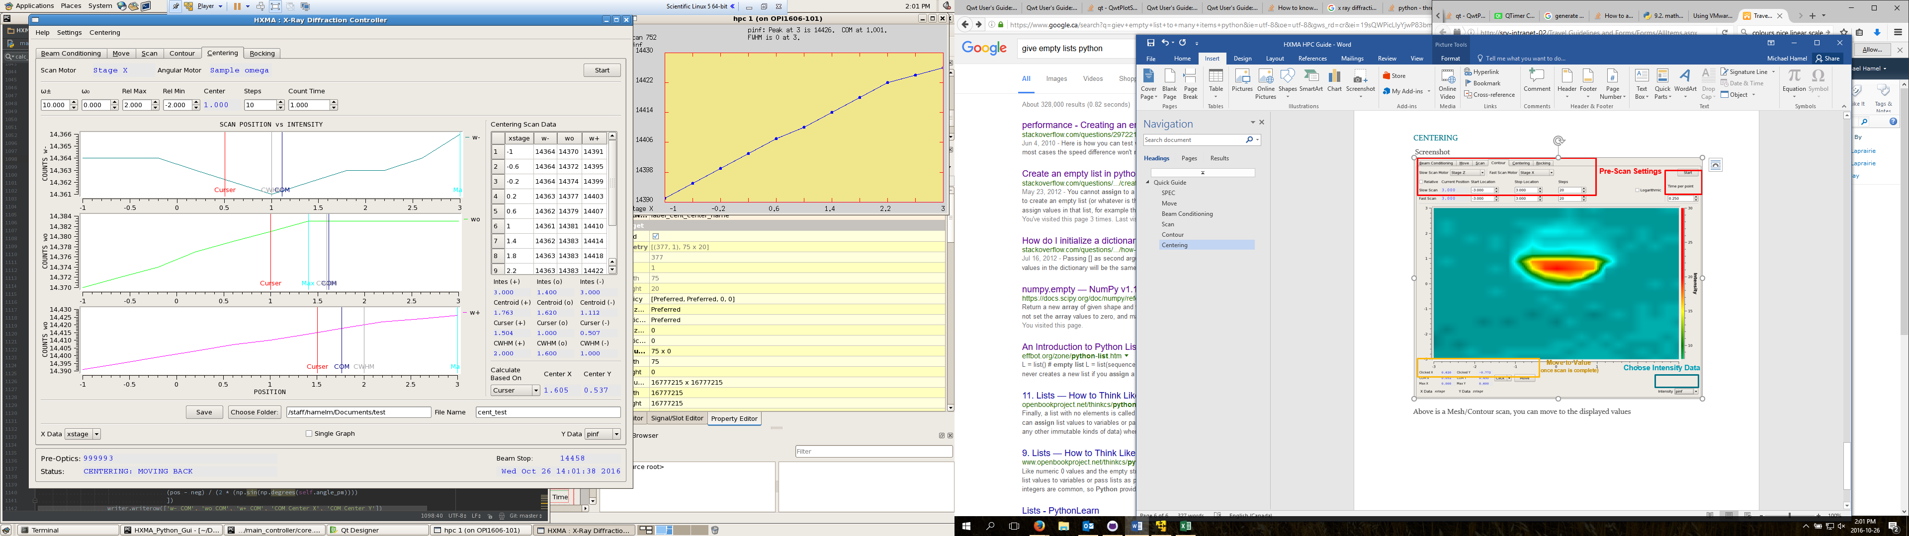

Above is a centering scan which is used to find the center of rotation from angular turns, a progression of small to large angle turns with a correction between each is recommended.

Saving will copy the table into a csv. Backups of each scan are saved individually if a folder is chosen.

The centering menu at the top is where you will choose your motors, this is done as we need a certain motor config, and once you choose your motors it will be saved between sessions.

## Rocking

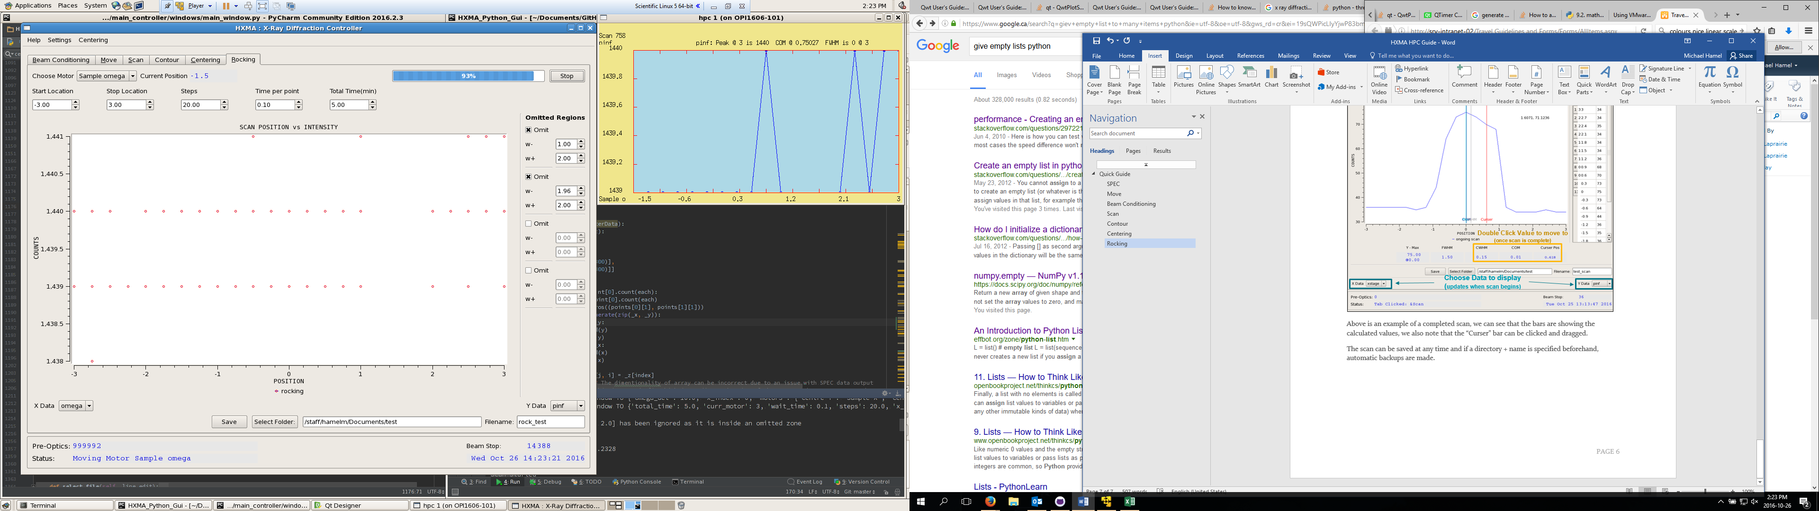

**Choose Data to display**

**(updates when scan begins)**

**Pre-Scan Settings**

Above is an example of an ongoing rocking scan, which is simply background.

The rocking scan will go back and forth between the two values skipping over any omitted regions. When the time is up (progress bar completes) the last scan will complete and the rocking will be done.

# Setup

Most important settings are saved in between sessions, and hence have been omitted from the Quick Guide. This properties file will be saved under ‘.Press2Diff/settings.json’. All of these settings are completed through the GUI, and is what this section covers.

## Motor Setup

When you load up the GUI without the settings loaded you will see that all unset motors look like 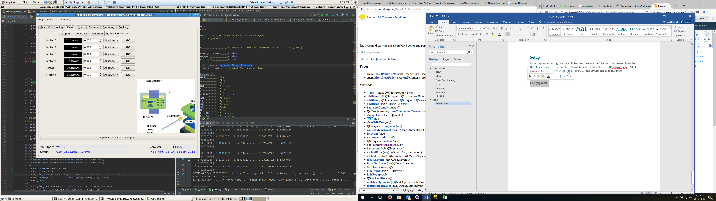This will occur in the BeamConditioning->SPEC tab and the Move Tab.

To set these motors choose Settings->Motor Slots in the toolbar:

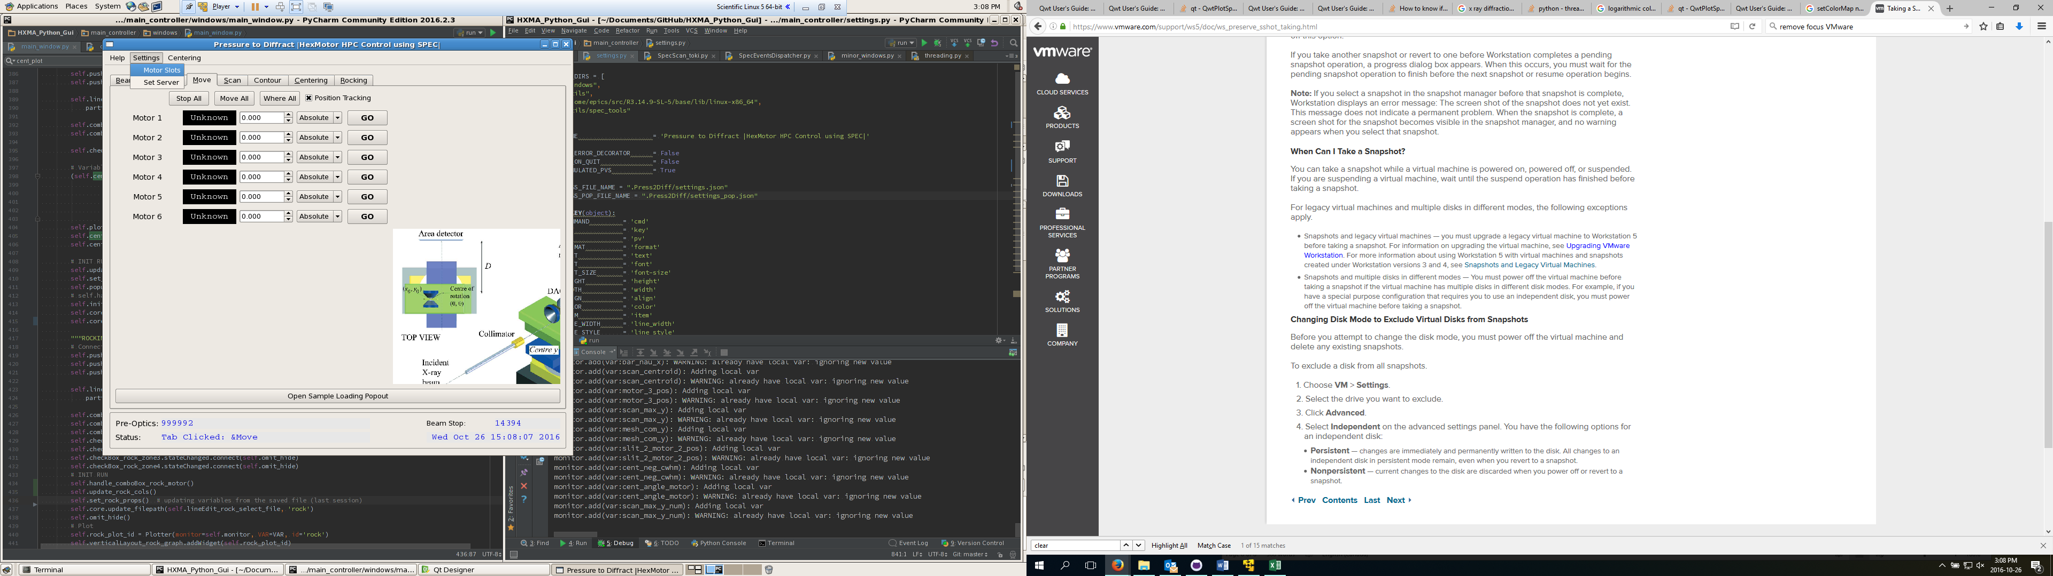

This will open:

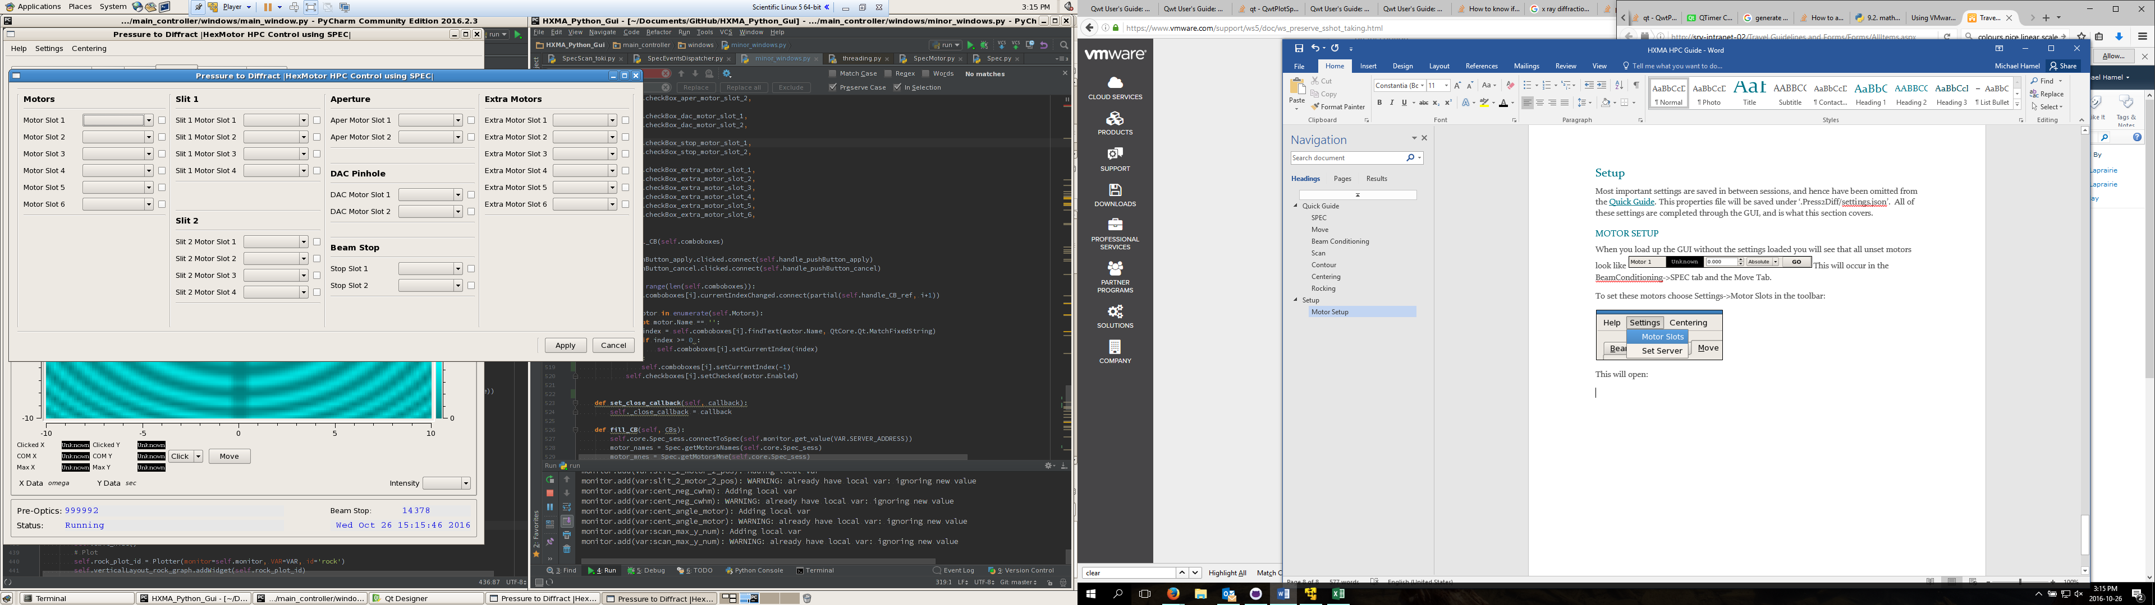

The far left Motor slots are the 6 stage controls which can be used with centering and rocking, the rest are conditioning motors which can be used with scans and contours. All Motors configured in SPEC will show up here in the combo boxes. You have to press the x next to the box to enable the motor, and apply to set it up.

This is also how you change motors.

Extra Motors are provided for future motors which may need contour maps and scans.

## Loading Positions

When centering a location is found for each cell which describes the rotational center of the cell. Hence when changing cells it is important to be able to save/recall the cell positions. This is what the following popup is for.

The button is found on the bottom of the Move Tab.

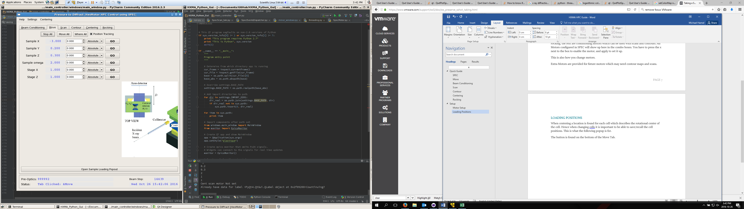

The popout looks like: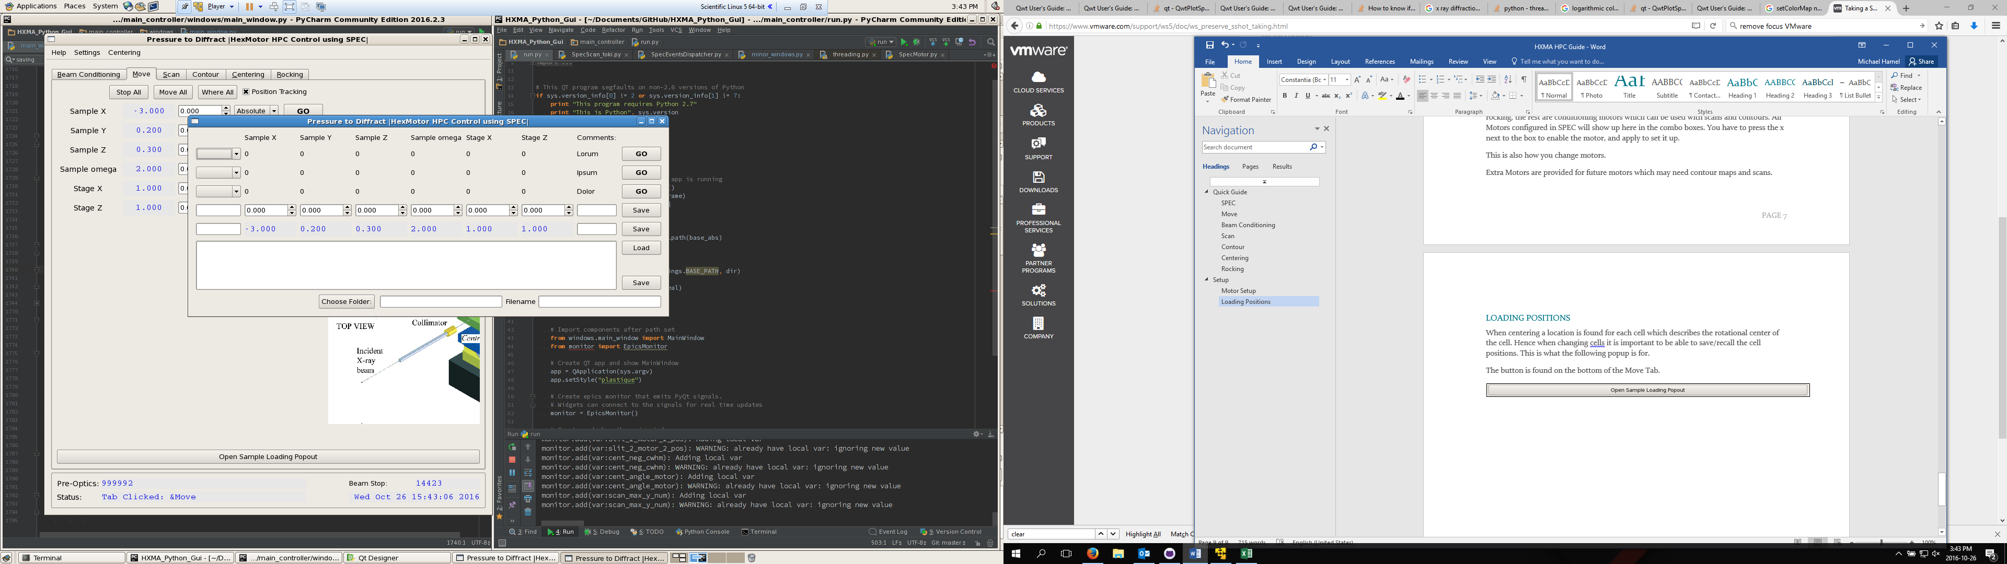

And when filled:

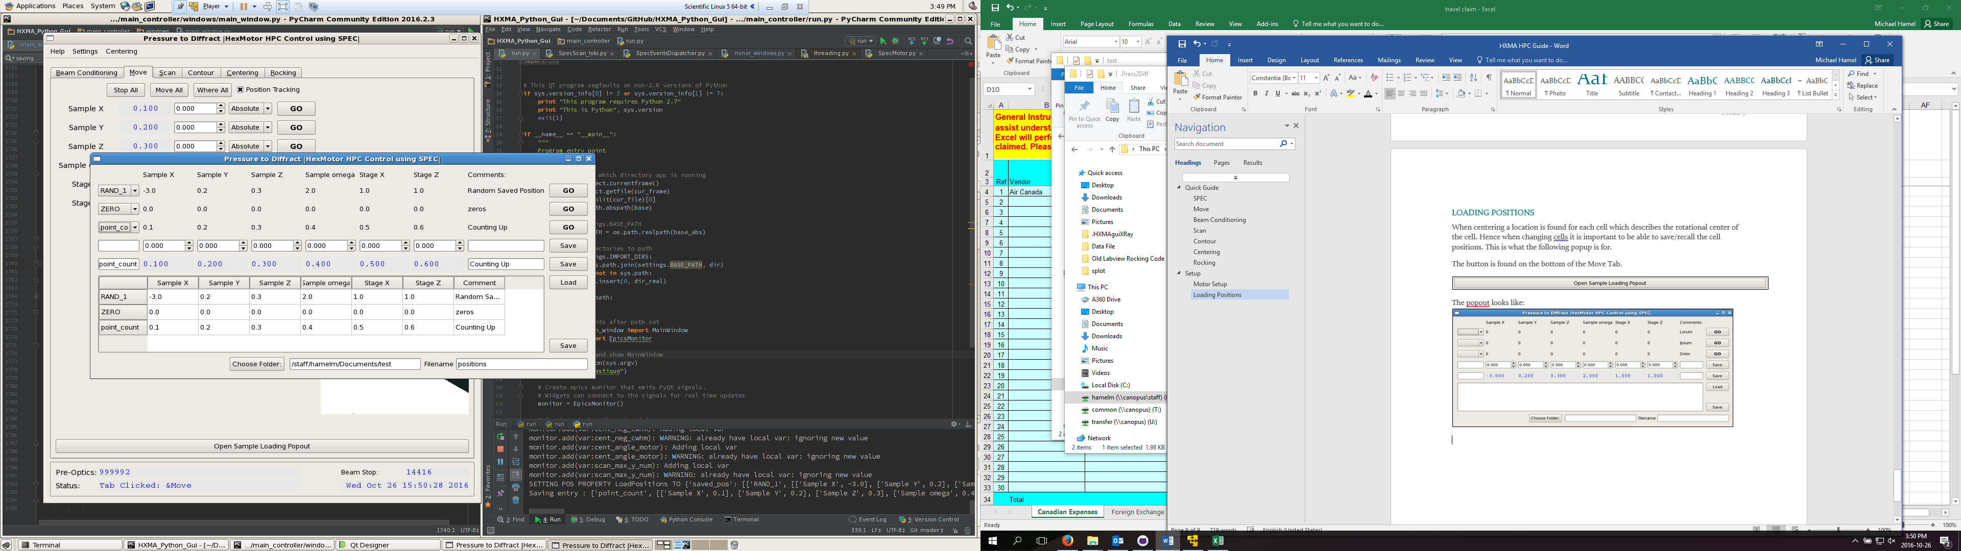

It allows you to save positions based off of the current or custom position, and will allow the loading/moving to one of these positions.

The whole sheet can also be loaded and saved from file. It is a csv which can be opened/edited by any text editor (ex. Excel, Notepad, Notepad++).

## Centering Motors

The centering algorithm requires 4 motors to be defined, (Z stage and Z sample are simply scanned). These are highlighted shown below.

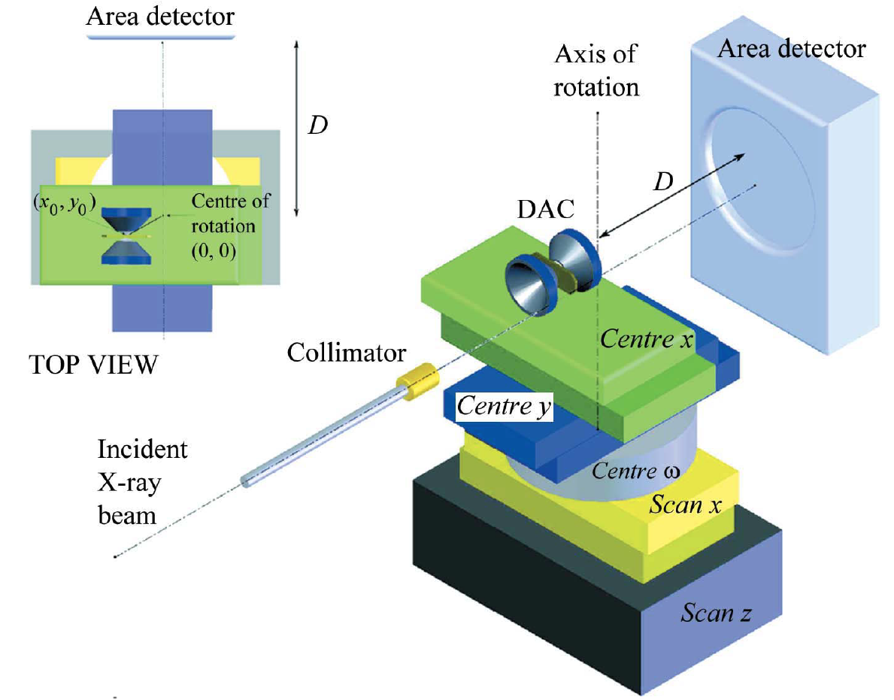

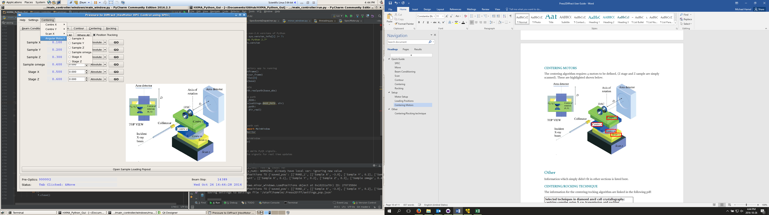

From the toolbar -> Centering we can set all four of these relevant motors, from the 6 motors in the move tab. If you see no motors check Motor Setup.

# Detailed Guide

This is mostly a guide of how the program works so it will not be necessary for operations, but may be helpful for troubleshooting or understanding limitations of the program.

## SPEC

The actual running of the SPEC server is not the focus here, for the purposes of my program we need to know that SPEC is a piece of software which monitors motors and detectors. We connect to this software remotely and this allows us to run the software we need.

The connections are done with a framework which looks like it was written by Matias Guijarro and allow us to send commands and receive data from SPEC. The backend is not perfect and needed to be developed for our usage. Every command passed to the client is done with the intention of keeping interactivity. This means that nothing will hold the server, and in fact if we send too many commands to the server or hold it we will get issues.

Generally we do a connection to SPEC at the beginning and close at the end, and every time a new Motor or scan needs to be completed we connect the relevant pieces. We also have a framework to send commands straight to SPEC, which allows custom macros to be programmed off of individual button presses.

The SPEC backend works well, but does seem to break every once and a while, this shows up by the counter giving empty (e-300) results or a segmentation fault. Generally, by restarting both clients this will be resolved.

## Motors

The motors which I will be referring to are the SPEC Motors, the EPICS motors which are found in Beam Conditioning are simply variables stored on site so we can read and write to them to move the motors, we can only move them and not scan them.

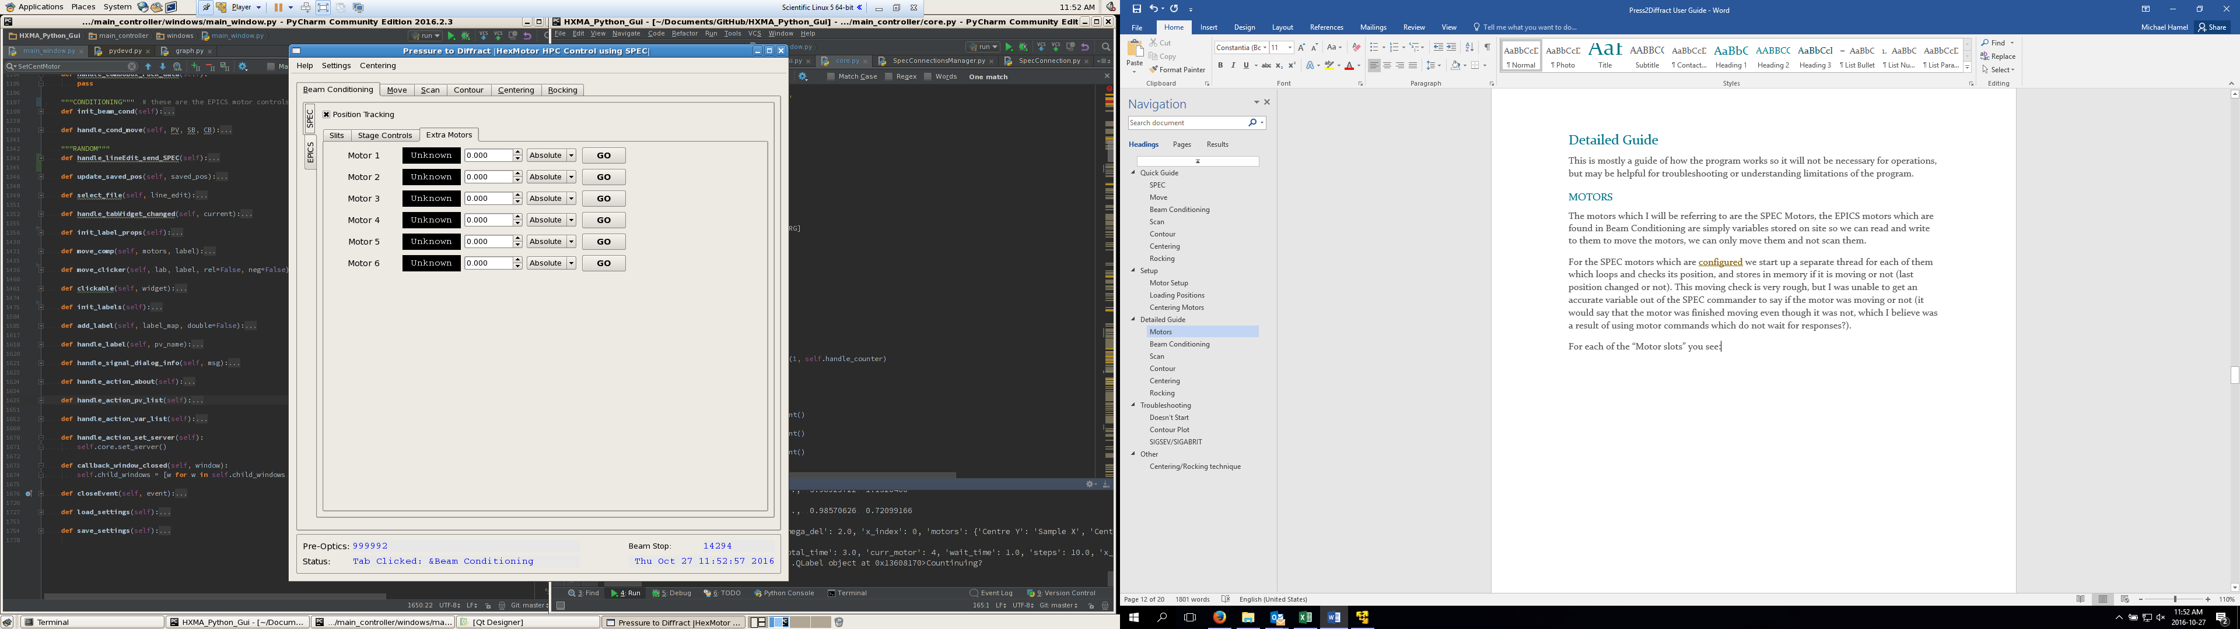For the SPEC motors which are configured we start up a separate thread for each of them which loops and checks its position, and stores in memory if it is moving or not (last position changed or not). This moving check is very rough, but I was unable to get an accurate variable out of the SPEC commander to say if the motor was moving or not (it would say that the motor was finished moving even though it was not, which I believe was a result of using motor commands which do not wait for responses?).

For each of the “Motor slots” you see: (ex: ) we have 5 on screen elements which must be set to a Motor if it is chosen. We do this by keeping information of all of the motor slots and when assigning them we link the motors data with that of the slots. This allows us to switch the motors and be flexable with scans as well.

## Scans

Every scan is unique but they all run on the same principle of running a separate thread which will manage the running of it and checking of new points, and another which will graph it.

# Troubleshooting

Here is a list of the currently known issues or possible errors I have encountered while testing the program.

## Doesn’t Start

“I started the program and nothing happens”

Please check the log file and see what the last message is. If it is:

” SETTING SERVER ADDRESS MainWindow TO…” This means that the SPEC server is not started or is incorrectly configured.

First try starting SPEC.

Second check the SPEC server is using 10.52.36.1:8585 (OPI1606-101:8585). If it is not change the SPEC server to run on this as it will always default to this when failing.

If you cannot change the server to run on this computer you will have to complete a workaround. There are two options:

For the first method you would need access to the code. Go to line 1451 of core.py and put in the appropriate server/port, this will change the default to this address.

For the second you need to change the settings.json, go to the .Press2Diff/settings.json and paste :

{

"MainWindow": {

"__server_address__": {

"host": "10.52.36.1",

"port": "8585"

},

"__window_rectangle__": {

"h": 1024,

"w": 720,

"x": 10,

"y": 10

}

}

}

Replace the host and port with the relevant host/port.

## Contour Plot

“I started the scan and it’s not displaying anything!”

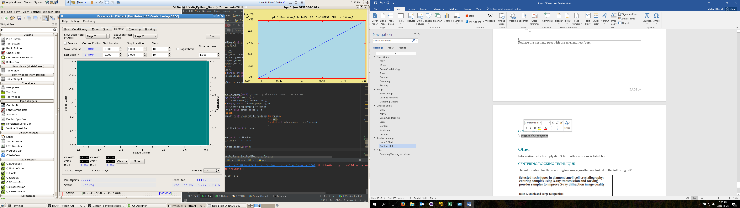

If the plot is displaying something like the above, this means that the detector has not managed to pickup any details of the sample(ex. Monitor is only picking up consistent values of 1). This often happens at the beginning of the scan and will generally resolve itself. You should also check the Intensity is set to the detector which you want to monitor (‘sec’ will always display this)

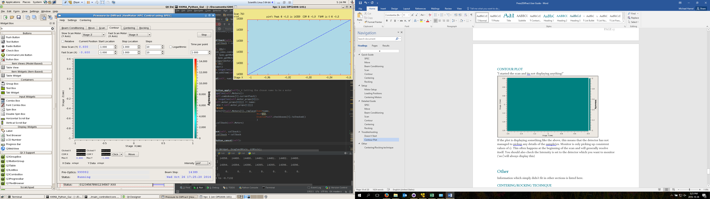

This is a different visual bug which I have been unable to fix, if you zoom in (hold and drag) you will be able to see the picture, and once it scans the row it has a good chance of fixing the issue.

## SIGSEV/SIGABRIT

“Program randomly crashed and the last line in the log is SIGSEV or SIGABRIT”

I am sorry, there is no fix for this issue, I spent quite a few days attempting to fix this issue and at this moment I believe it is fixed. If you are reading this it obviously is not.

This is a memory access error and [notoriously rare/difficult to fix](https://wiki.python.org/moin/CrashingPython). Turning off Position Tracking and increasing the time spent on each point *may* help.

# Other

Information which simply didn’t fit in other sections is listed here.

## Centering/Rocking technique

The information for the centering/rocking algorithm are linked in the following pdf:



(Double click to open)

Pages 3-5 describe centering and Pages 9- talk about rocking.

## Missing Features

These are generally the things that should be added:

More information to scans,

Single Rock option

Shutter

MAR345 interface